# **ECEN 215 – PRIN OF ELECTRICAL ENGR**

# **Spring 2019**

## **Lab 7: Operational Amplifier Integrator and Active Filter**



**Submitted by:**

|  |  |  |
| --- | --- | --- |
| **Student Name** | **UIN:** | **Section #** |
| Daniel Lopez | 426001591 | 516 |
| Adam Johnston | 516007336 |
| Jared Blunt | 524009660 |  |

**Date Performed: April 15th, 2019**

1. **Objective**

This lab is as an introduction to the concept of using Operational Amplifiers (Op Amps) as active filters in circuits. It incorporates it also shows how Op Amps are able, not only to amplify signals; it presents their ability to invert the source input signal from positive to negative or vice versa.This lab primarily shows how input waves affect the output waves. It does this by showing what the the output waves are for inputs: sine, square and triangle.

1. **Procedure**
2. Build the circuit depicted in figure 7.2b (note: use two 10kΩ in // to achieve 5kΩ resistance)
3. Measure and record the resistance of the values of all components using a multimeter
4. Connect the circuit to the Analog Discovery
   1. Set the input voltage to be .5 Volts (AC)
   2. Ensuring that +5V and -5V are in the correct inputs
5. Screenshot WaveForm and Logger results
   1. Using Sine Wave
   2. Using Square Wave
   3. Using Triangle Wave

1. **Difficulties**
2. Damaged components
3. Components with different values than what was needed for the lab
4. Being unable to measure individuals inductors
5. Difficulty keeping wires inside the Analog Discovery
6. Issues with the WaveForms software giving incorrect data
7. **Results**

**Initial Conditions**

|  |  |  |  |  |  |  |
| --- | --- | --- | --- | --- | --- | --- |
| **R1** | **R2** | **Capacitor** | **Frequency** | **Amplitude** | **Offset** | **Phase Shift** |
| 986 Ω | 986 Ω | 100 μF | 30 Hz | 0.5 V | 0 V | 0° |

**Bread Board - Circuit 7.2b**

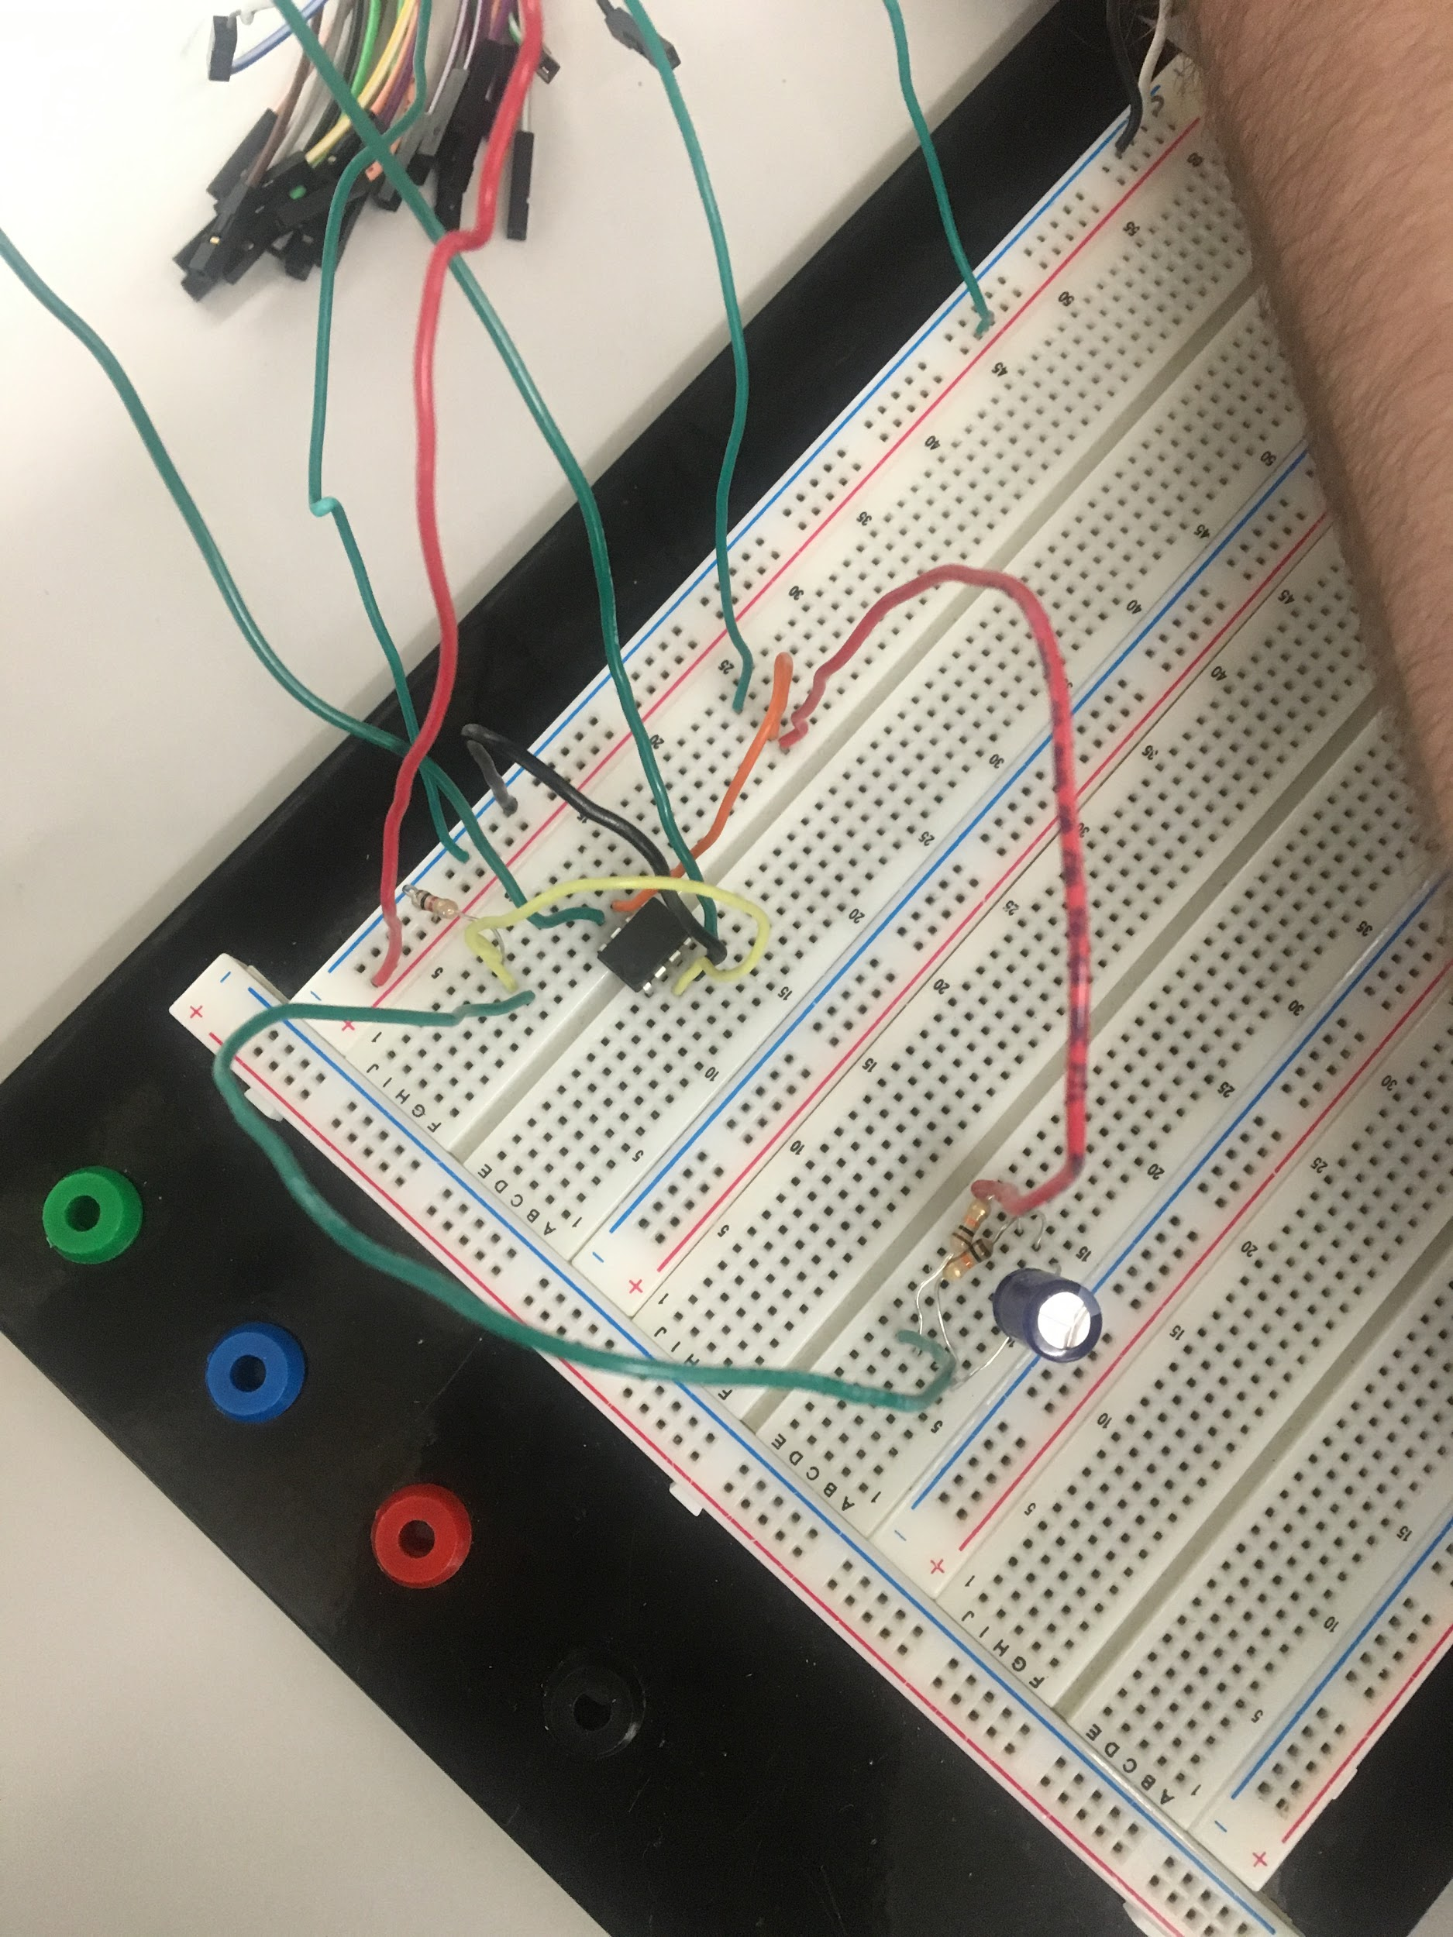

**Sine Wave Scope**

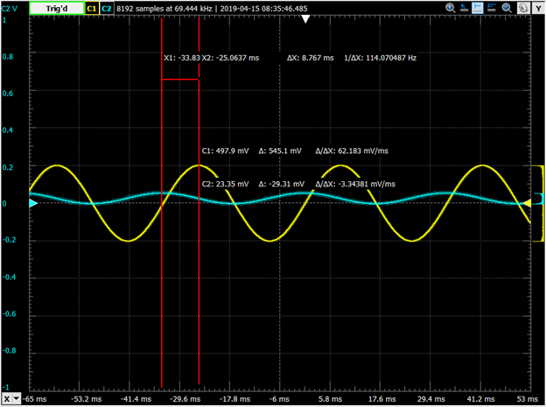

**Sine Wave Logger**

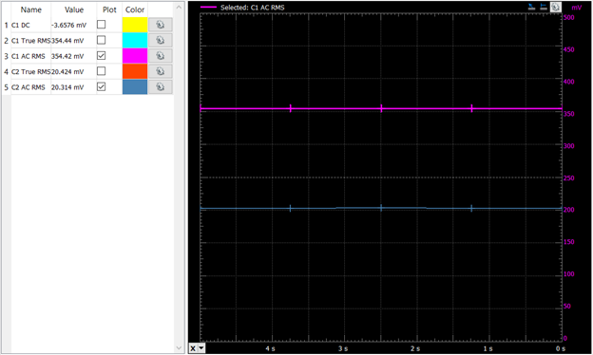

**Square Wave Scope**

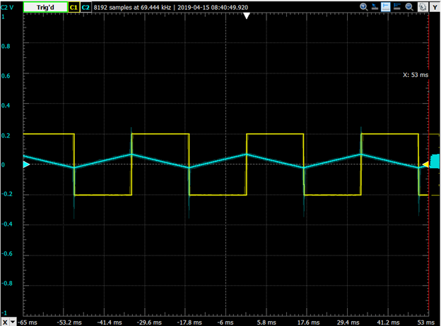

**Square Wave Logger**

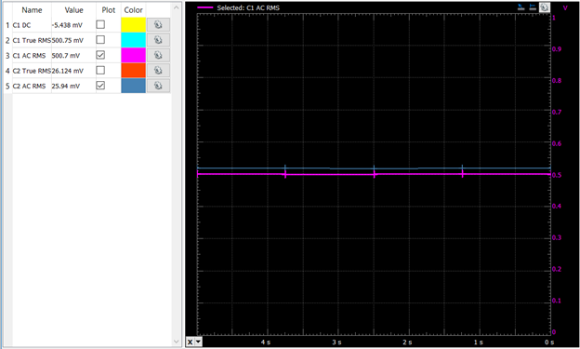

**Triangle Wave Scope**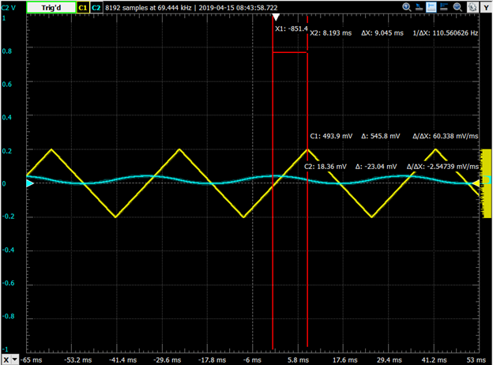

**Triangle Wave Logger**

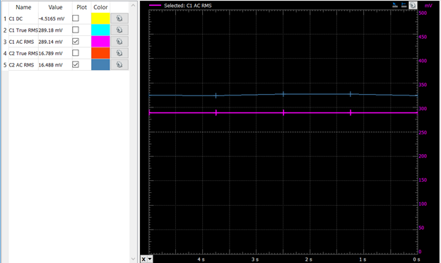

1. **Conclusion**

In conclusion our experiment was a success. We were able to fully simulate and understand operational amplifier integrator and active filter and how they work in a circuit for not only a sine wave but for a square and triangle wave as well. This experiment helped us to grasp a better understanding that cemented what knowledge we had acquired from class. Although this lab was a success there was still room for error. For example, we may have made an error in our calculations. Also some of the wires were not functioning properly and had to be replaced in order for the lab to function properly.